**Note**: Consider the following before starting the assignment:

* A **static field** declared inside a class is called a **class-level variable**. To access this variable, use the class name and the dot operator (e.g., Integer.MAX_VALUE).
* A **static method** defined inside a class is called a **class-level method**. To access this method, use the class name and the dot operator (e.g., Integer.parseInt()).
* When accessing static members within the same class, you do not need to use the class name.

#### ****1. Working with**** java.lang.Boolean

**a.** Explore the [Java API documentation for java.lang.Boolean](https://docs.oracle.com/javase/8/docs/api/java/lang/Boolean.html) and observe its modifiers and super types.

* public final class **Boolean –** public modifier.
* [java.lang.Object](https://docs.oracle.com/javase/8/docs/api/java/lang/Object.html) is the superclass of java.lang.Boolean.

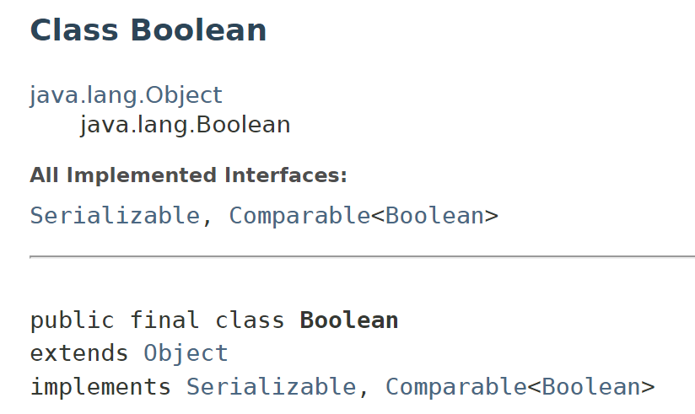

**b.** Declare a method-local variable status of type boolean with the value true and convert it to a String using the toString method. (Hint: Use Boolean.toString(Boolean) ).

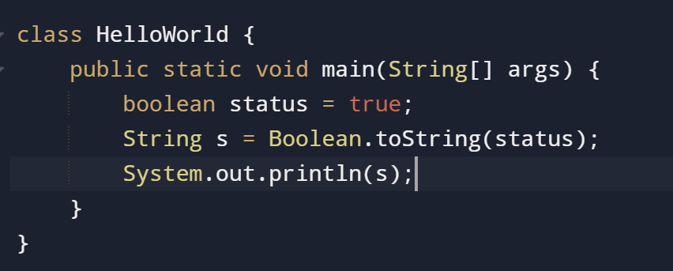

**Output :**



**c.** Declare a method-local variable strStatus of type String with the value "true" and convert it to a boolean using the parseBoolean method. (Hint: Use Boolean.parseBoolean(String)).

* For any other value, including "farah", "false", or an empty string, it will return false.

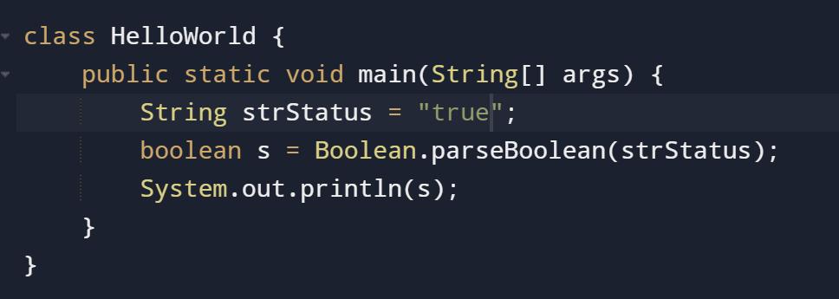

**Output :**



**d.** Declare a method-local variable strStatus of type String with the value "1" or "0" and attempt to convert it to a boolean. (Hint: parseBoolean method will not work as expected with "1" or "0").

* Same for 1 also it give false or any other value.

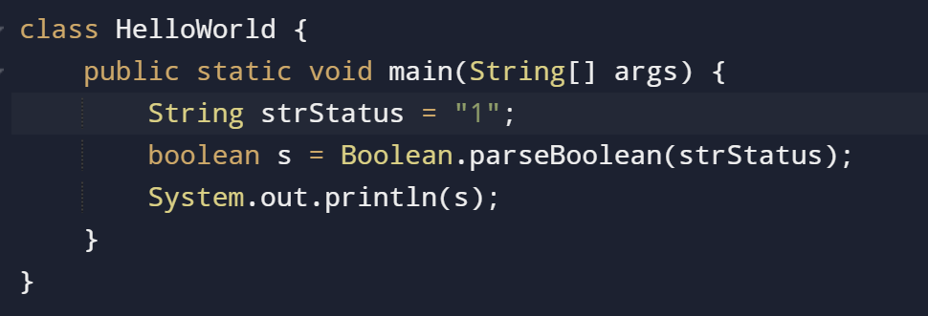

**Output :**



**e.** Declare a method-local variable status of type boolean with the value true and convert it to the corresponding wrapper class using Boolean.valueOf(). (Hint: Use Boolean.valueOf(boolean)).

* Boxing is the process of converting value of variable of primitive type into non primitive type.

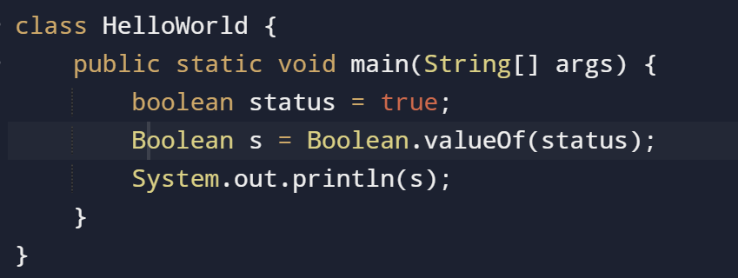

**f.** Declare a method-local variable strStatus of type String with the value "true" and convert it to the corresponding wrapper class using Boolean.valueOf(). (Hint: Use Boolean.valueOf(String)).

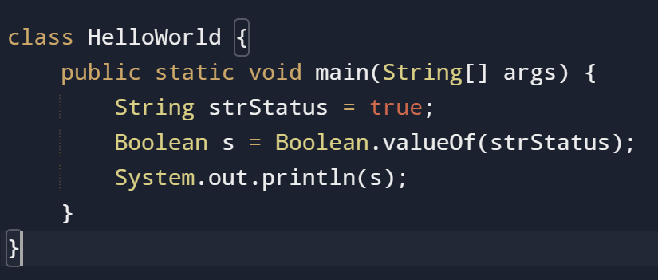

**Output :**



**g.** Experiment with converting a boolean value into other primitive types or vice versa and observe the results.

#### ****2. Working with**** java.lang.Byte

**a.** Explore the [Java API documentation for java.lang.Byte](https://docs.oracle.com/javase/8/docs/api/java/lang/Byte.html) and observe its modifiers and super types.

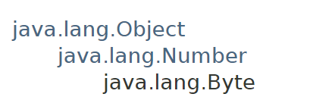

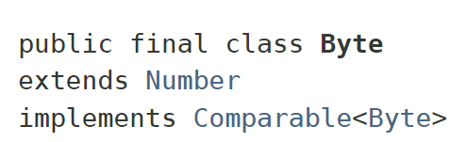

**b.** Write a program to test how many bytes are used to represent a byte value using the BYTES field. (Hint: Use Byte.BYTES).

* Will give the size in bytes-

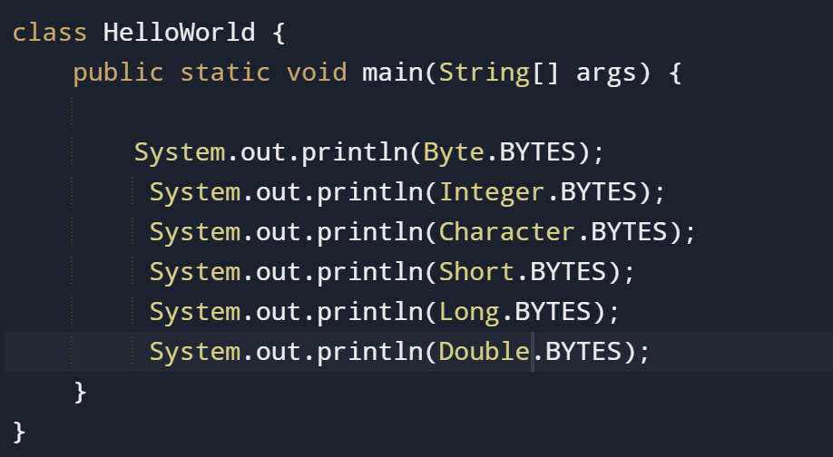

**Output:**



**c.** Write a program to find the minimum and maximum values of byte using the MIN_VALUE and MAX_VALUE fields. (Hint: Use Byte.MIN_VALUE and Byte.MAX_VALUE).

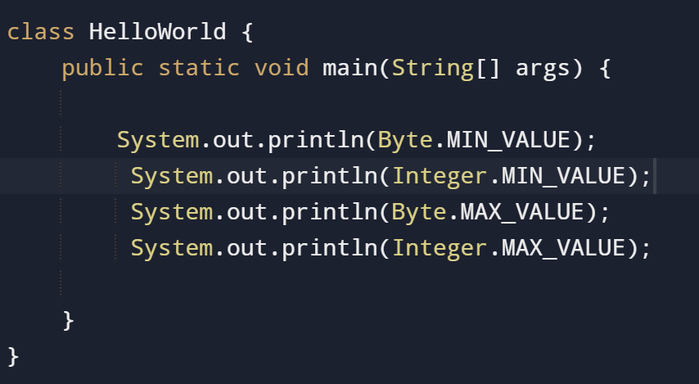

**Output:**

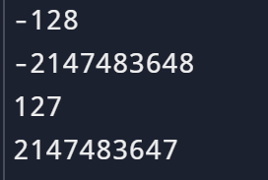

**d.** Declare a method-local variable number of type byte with some value and convert it to a String using the toString method. (Hint: Use Byte.toString(byte)).

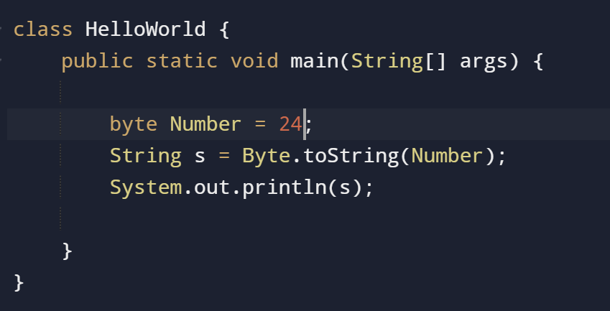

**Output:** 24

**e.** Declare a method-local variable strNumber of type String with some value and convert it to a byte value using the parseByte method. (Hint: Use Byte.parseByte(String)).

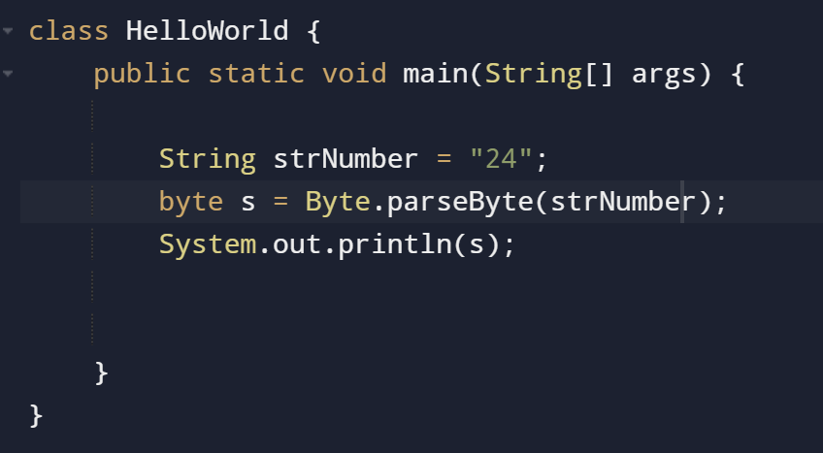

**Output:** 24

**NOTE: We took String here- String strNumber = “24”;**

**f.** Declare a method-local variable strNumber of type String with the value "Ab12Cd3" and attempt to convert it to a byte value. (Hint: parseByte method will throw a NumberFormatException).

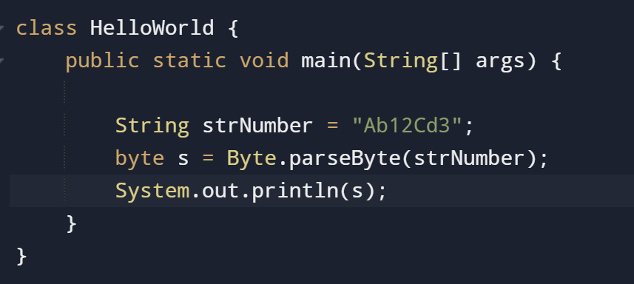

**Output:**

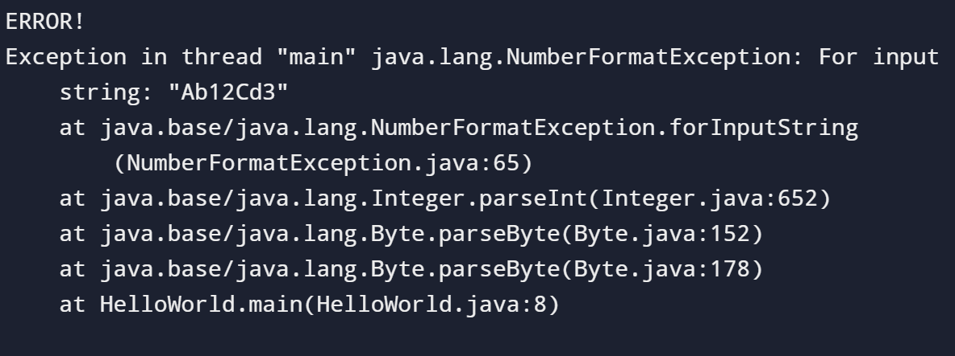

**g.** Declare a method-local variable number of type byte with some value and convert it to the corresponding wrapper class using Byte.valueOf(). (Hint: Use Byte.valueOf(byte)).

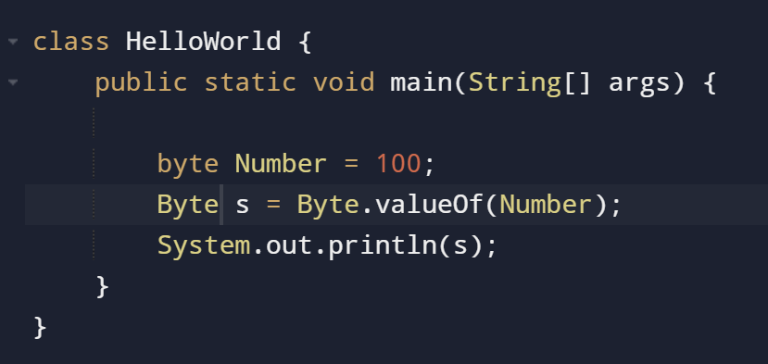

**Output:** 100

**h.** Declare a method-local variable strNumber of type String with some byte value and convert it to the corresponding wrapper class using Byte.valueOf(). (Hint: Use Byte.valueOf(String)).

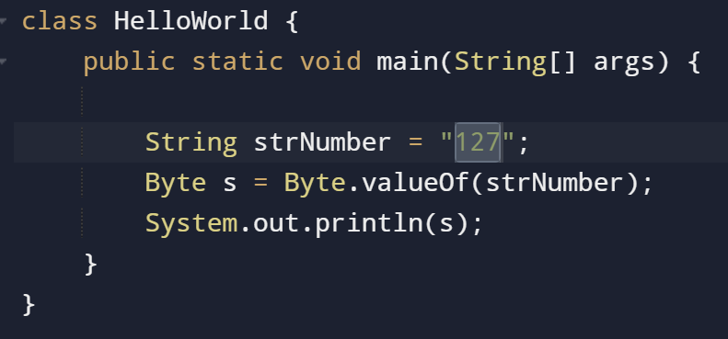

**Output:** 127

**i.** Experiment with converting a byte value into other primitive types or vice versa and observe the results.

**Widening.**

Converting byte to other Datatype.

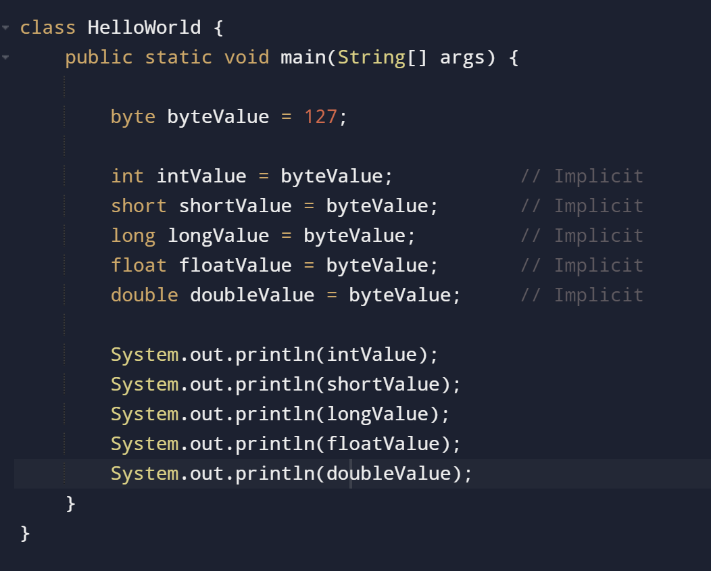

**Output:**

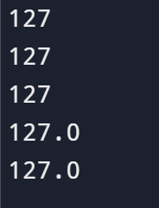

**Narrowing.**

Converting other datatypes to byte.

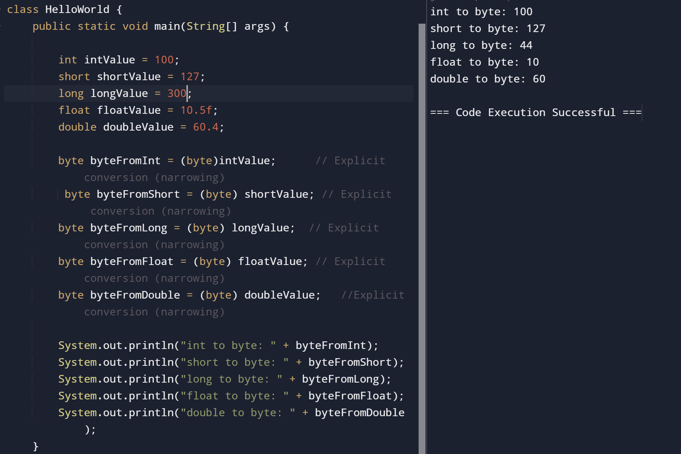

#### ****3. Working with**** java.lang.Short

**a.** Explore the [Java API documentation for java.lang.Short](https://docs.oracle.com/javase/8/docs/api/java/lang/Short.html) and observe its modifiers and super types.

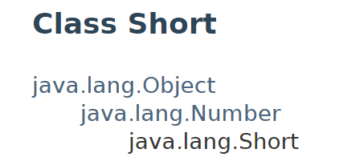

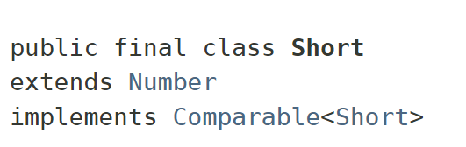

**b.** Write a program to test how many bytes are used to represent a short value using the BYTES field. (Hint: Use Short.BYTES).

**c.** Write a program to find the minimum and maximum values of short using the MIN_VALUE and MAX_VALUE fields. (Hint: Use Short.MIN_VALUE and Short.MAX_VALUE).

**d.** Declare a method-local variable number of type short with some value and convert it to a String using the toString method. (Hint: Use Short.toString(short)).

**e.** Declare a method-local variable strNumber of type String with some value and convert it to a short value using the parseShort method. (Hint: Use Short.parseShort(String)).

**f.** Declare a method-local variable strNumber of type String with the value "Ab12Cd3" and attempt to convert it to a short value. (Hint: parseShort method will throw a NumberFormatException).

**g.** Declare a method-local variable number of type short with some value and convert it to the corresponding wrapper class using Short.valueOf(). (Hint: Use Short.valueOf(short)).

**h.** Declare a method-local variable strNumber of type String with some short value and convert it to the corresponding wrapper class using Short.valueOf(). (Hint: Use Short.valueOf(String)).

**i.** Experiment with converting a short value into other primitive types or vice versa and observe the results.

#### ****4. Working with**** java.lang.Integer

**a.** Explore the [Java API documentation for java.lang.Integer](https://docs.oracle.com/javase/8/docs/api/java/lang/Integer.html) and observe its modifiers and super types.

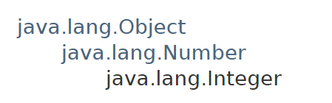

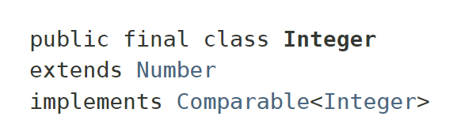

**b.** Write a program to test how many bytes are used to represent an int value using the BYTES field. (Hint: Use Integer.BYTES).

**c.** Write a program to find the minimum and maximum values of int using the MIN_VALUE and MAX_VALUE fields. (Hint: Use Integer.MIN_VALUE and Integer.MAX_VALUE).

**d.** Declare a method-local variable number of type int with some value and convert it to a String using the toString method. (Hint: Use Integer.toString(int)).

**e.** Declare a method-local variable strNumber of type String with some value and convert it to an int value using the parseInt method. (Hint: Use Integer.parseInt(String)).

**f.** Declare a method-local variable strNumber of type String with the value "Ab12Cd3" and attempt to convert it to an int value. (Hint: parseInt method will throw a NumberFormatException).

**g.** Declare a method-local variable number of type int with some value and convert it to the corresponding wrapper class using Integer.valueOf(). (Hint: Use Integer.valueOf(int)).

**h.** Declare a method-local variable strNumber of type String with some integer value and convert it to the corresponding wrapper class using Integer.valueOf(). (Hint: Use Integer.valueOf(String)).

**i.** Declare two integer variables with values 10 and 20, and add them using a method from the Integer class. (Hint: Use Integer.sum(int, int)).

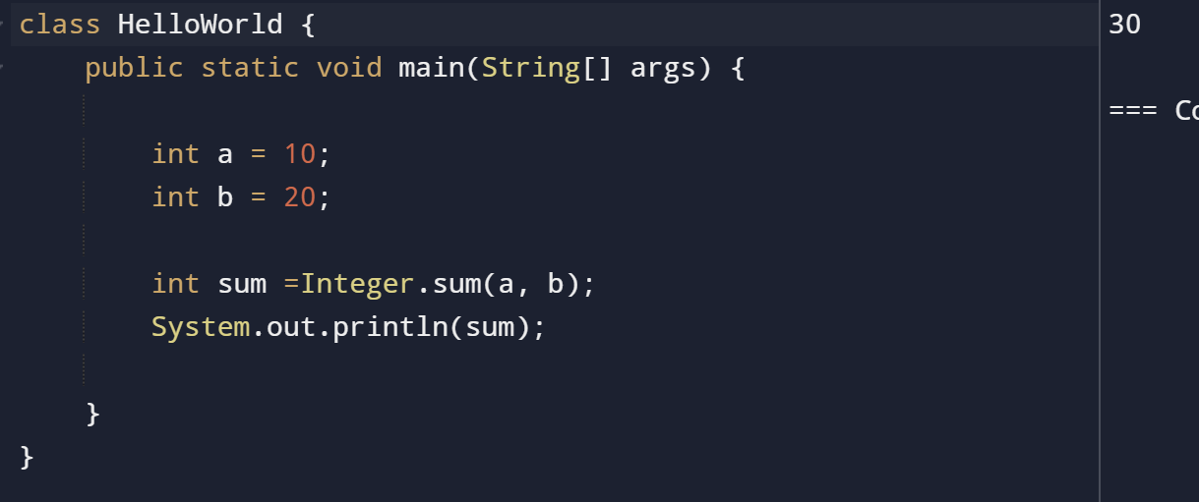

**j.** Declare two integer variables with values 10 and 20, and find the minimum and maximum values using the Integer class. (Hint: Use Integer.min(int, int) and Integer.max(int, int)).

**k.** Declare an integer variable with the value 7. Convert it to binary, octal, and hexadecimal strings using methods from the Integer class. (Hint: Use Integer.toBinaryString(int), Integer.toOctalString(int), and Integer.toHexString(int)).

**l.** Experiment with converting an int value into other primitive types or vice versa and observe the results.

#### ****5. Working with**** java.lang.Long

**a.** Explore the [Java API documentation for java.lang.Long](https://docs.oracle.com/javase/8/docs/api/java/lang/Long.html) and observe its modifiers and super types.

**b.** Write a program to test how many bytes are used to represent a long value using the BYTES field. (Hint: Use Long.BYTES).

**c.** Write a program to find the minimum and maximum values of long using the MIN_VALUE and MAX_VALUE fields. (Hint: Use Long.MIN_VALUE and Long.MAX_VALUE).

**d.** Declare a method-local variable number of type long with some value and convert it to a String using the toString method. (Hint: Use Long.toString(long)).

**e.** Declare a method-local variable strNumber of type String with some value and convert it to a long value using the parseLong method. (Hint: Use Long.parseLong(String)).

**f.** Declare a method-local variable strNumber of type String with the value "Ab12Cd3" and attempt to convert it to a long value. (Hint: parseLong method will throw a NumberFormatException).

**g.** Declare a method-local variable number of type long with some value and convert it to the corresponding wrapper class using Long.valueOf(). (Hint: Use Long.valueOf(long)).

**h.** Declare a method-local variable strNumber of type String with some long value and convert it to the corresponding wrapper class using Long.valueOf(). (Hint: Use Long.valueOf(String)).

**i.** Declare two long variables with values 1123 and 9845, and add them using a method from the Long class. (Hint: Use Long.sum(long, long)).

**j.** Declare two long variables with values 1122 and 5566, and find the minimum and maximum values using the Long class. (Hint: Use Long.min(long, long) and Long.max(long, long)).

**k.** Declare a long variable with the value 7. Convert it to binary, octal, and hexadecimal strings using methods from the Long class. (Hint: Use Long.toBinaryString(long), Long.toOctalString(long), and Long.toHexString(long)).

**l.** Experiment with converting a long value into other primitive types or vice versa and observe the results.

#### ****6. Working with**** java.lang.Float

**a.** Explore the [Java API documentation for java.lang.Float](https://docs.oracle.com/javase/8/docs/api/java/lang/Float.html) and observe its modifiers and super types.

**b.** Write a program to test how many bytes are used to represent a float value using the BYTES field. (Hint: Use Float.BYTES).

**c.** Write a program to find the minimum and maximum values of float using the MIN_VALUE and MAX_VALUE fields. (Hint: Use Float.MIN_VALUE and Float.MAX_VALUE).

**d.** Declare a method-local variable number of type float with some value and convert it to a String using the toString method. (Hint: Use Float.toString(float)).

**e.** Declare a method-local variable strNumber of type String with some value and convert it to a float value using the parseFloat method. (Hint: Use Float.parseFloat(String)).

**f.** Declare a method-local variable strNumber of type String with the value "Ab12Cd3" and attempt to convert it to a float value. (Hint: parseFloat method will throw a NumberFormatException).

**g.** Declare a method-local variable number of type float with some value and convert it to the corresponding wrapper class using Float.valueOf(). (Hint: Use Float.valueOf(float)).

**h.** Declare a method-local variable strNumber of type String with some float value and convert it to the corresponding wrapper class using Float.valueOf(). (Hint: Use Float.valueOf(String)).

**i.** Declare two float variables with values 112.3 and 984.5, and add them using a method from the Float class. (Hint: Use Float.sum(float, float)).

**j.** Declare two float variables with values 112.2 and 556.6, and find the minimum and maximum values using the Float class. (Hint: Use Float.min(float, float) and Float.max(float, float)).

**k.** Declare a float variable with the value -25.0f. Find the square root of this value. (Hint: Use Math.sqrt() method).

**l.** Declare two float variables with the same value, 0.0f, and divide them. (Hint: Observe the result and any special floating-point behavior).

**m.** Experiment with converting a float value into other primitive types or vice versa and observe the results.

#### ****7. Working with**** java.lang.Double

**a.** Explore the [Java API documentation for java.lang.Double](https://docs.oracle.com/javase/8/docs/api/java/lang/Double.html) and observe its modifiers and super types.

**b.** Write a program to test how many bytes are used to represent a double value using the BYTES field. (Hint: Use Double.BYTES).

**c.** Write a program to find the minimum and maximum values of double using the MIN_VALUE and MAX_VALUE fields. (Hint: Use Double.MIN_VALUE and Double.MAX_VALUE).

**d.** Declare a method-local variable number of type double with some value and convert it to a String using the toString method. (Hint: Use Double.toString(double)).

**e.** Declare a method-local variable strNumber of type String with some value and convert it to a double value using the parseDouble method. (Hint: Use Double.parseDouble(String)).

**f.** Declare a method-local variable strNumber of type String with the value "Ab12Cd3" and attempt to convert it to a double value. (Hint: parseDouble method will throw a NumberFormatException).

**g.** Declare a method-local variable number of type double with some value and convert it to the corresponding wrapper class using Double.valueOf(). (Hint: Use Double.valueOf(double)).

**h.** Declare a method-local variable strNumber of type String with some double value and convert it to the corresponding wrapper class using Double.valueOf(). (Hint: Use Double.valueOf(String)).

**i.** Declare two double variables with values 112.3 and 984.5, and add them using a method from the Double class. (Hint: Use Double.sum(double, double)).

**j.** Declare two double variables with values 112.2 and 556.6, and find the minimum and maximum values using the Double class. (Hint: Use Double.min(double, double) and Double.max(double, double)).

**k.** Declare a double variable with the value -25.0. Find the square root of this value. (Hint: Use Math.sqrt() method).

**l.** Declare two double variables with the same value, 0.0, and divide them. (Hint: Observe the result and any special floating-point behavior).

**m.** Experiment with converting a double value into other primitive types or vice versa and observe the results.

#### ****8. Conversion between Primitive Types and Strings****

Initialize a variable of each primitive type with a user-defined value and convert it into String:

* + First, use the toString method of the corresponding wrapper class. (e.g., Integer.toString()).
  + Then, use the valueOf method of the String class. (e.g., String.valueOf()).

#### ****9. Default Values of Primitive Types****

Declare variables of each primitive type as fields of a class and check their default values. (Note: Default values depend on whether the variables are instance variables or static variables).

#### ****10. Arithmetic Operations with Command Line Input****

Write a program that accepts two integers and an arithmetic operator (+, -, *, /) from the command line. Perform the specified arithmetic operation based on the operator provided. (Hint: Use switch-case for operations).